- Purpose
  - The purpose of this document is to describe the procedure for assembling the pad plate on an orbital machine.
- Scope
  - This SOP applies to all equipment assembly team members. The process applies to the following machine ID’s:
E012801EQM0600BA1000 – Basic Sand Dragon, 20”
E012801EQM0607BE1200 – Crewman ORB 20
E012801EQM0607BA1200 – Basic Sand Dragon 20, Canadian
E012801EQM0607BE1200 – Crewman ORB 20, Canadian
E012806EQM0600BA1000 – Basic Sand Dragon, 20”, w/ Weights
E012806EQM0600BE1200 – Crewman ORB 20, w/Weights
E012806EQM0607BA1200 – Basic Sand Dragon 20, w/Weights, Canadian
E012806EQM0600BE1200 – Crewman ORB 20, w/Weights, Canadian
E012811EQM0600BA1000 – Basic Sand Dragon, 28”, w/Weights
E012811EQM0600BE1000 – Crewman 28 ORB, w/Weights
E012811EQM0607BA1200 – Basic Sand Dragon 28, w/Weights, Canadian
E012811EQM0607BE1200 – Crewman ORB 28, w/Weights Canadian
- Responsibilities
  - The operations manager/supervisor is responsible for enforcing this SOP.
- Materials
  - The proper materials needed for this process are listed on the machine work order.
- Definitions

- Procedure
  - Take a pad driver backing plate (89612 for a 20” machine or 89655 for a 28” machine) and wipe off the side that the pad will adhere to. Stick a flex lock pad (89712 for a 20” machine or 89713 for a 28” machine) to the side shown. There is no glue needed, just peel the back off of the flex lock. Note the orientation of the backing plate. The countersinks from the 8 center bolts should be up. Keep the center punchouts from the flex lock pad.

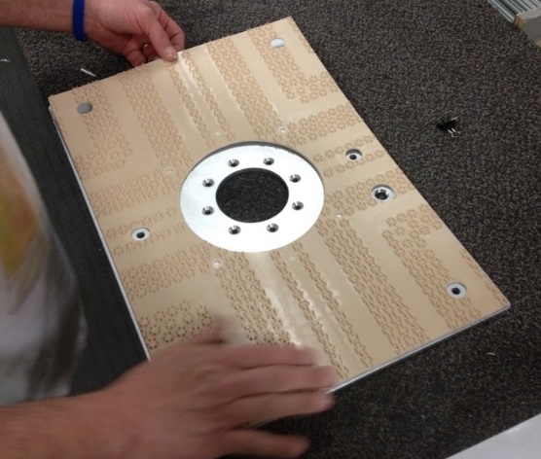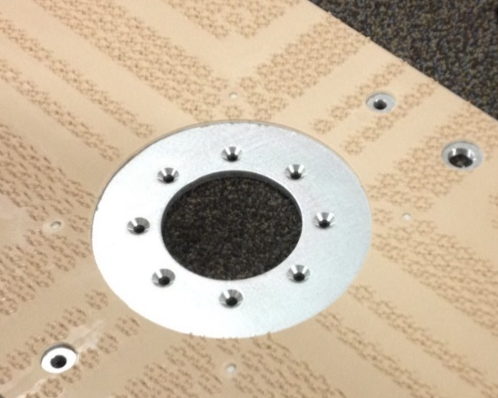
  - Thread a barbed fitting (10080) into the plate as shown.

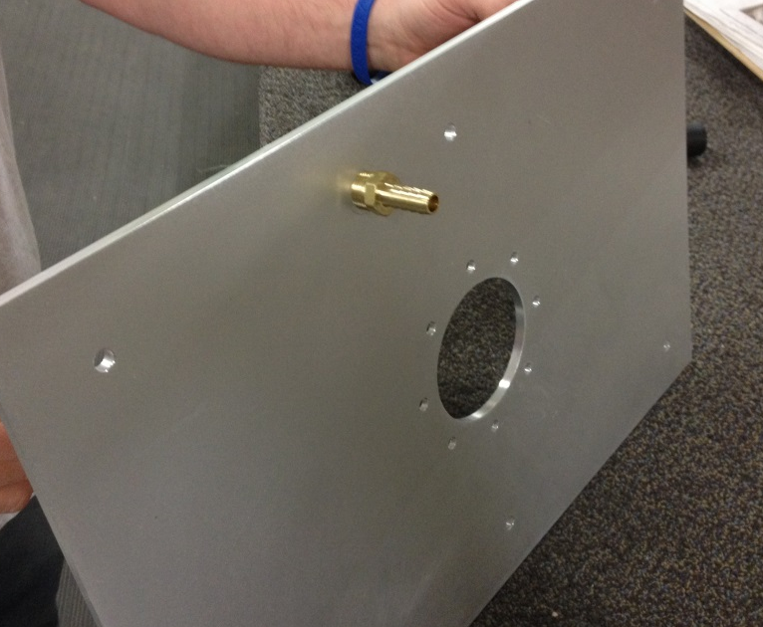

  - Take a bearing assembly (Refer to SOP EQ 083) and bolt it to the backing plate using 8 flat head screws (89685). Put blue Loctite onto the threads before installing.

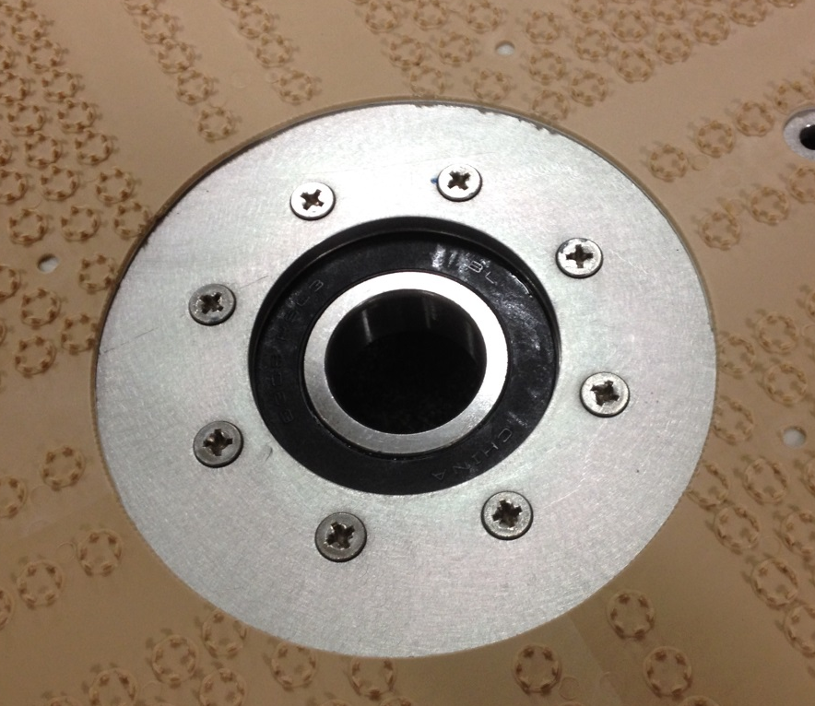

- References (optional section as needed)

- Training Guide

Functional Training Groups Requiring Training
Equipment Assembly Group

- SOP Change Control

Date of Change | Reason for Change
Rev 01 - 4/28/2015 | This is the first version of the S.O.P. hence there are no revisions to this document.
Rev 02 - 1/16/2018 | Added the Responsibilities Section
Rev 03 - 10/15/2024 | Updated Machine ID’s
Rev 04 - 3/6/2025 | Removed work center note and updated process

Approvals

Submitter/Author Approval:__________________________________ Date:______________________

Management Approval:______________________________________ Date:______________________

QAU Approval:_____________________________________________ Date:______________________

